Final Project: Digital Transformation Strategy for a Mid-sized Retail Chain
Instructions: Use this template to draft the project deliverables. You may modify the template to include more information.
Step I: Current system assessment
- System architecture overview
The retailer's current technology infrastructure is fragmented and heavily reliant on legacy systems:
- POS System: Windows CE-based terminals with outdated card reader drivers. Transactions take more than 5 seconds, causing slow checkouts.
- E-commerce: Magento 1.9 on a standalone MySQL database. Poor performance metrics include cumulative layout shifts over 0.25 and slow page loads on mobile networks.
- Data Storage: On-premise SQL databases per store. Nightly batch updates result in inconsistent and delayed data synchronization with headquarters.
- Inventory Management: Manually maintained through Excel spreadsheets. This leads to inefficient restocking and frequent stockouts.

- Pain-points matrix
Pain point | Impact | Root cause
Checkout delays | Reduced conversion rates | Slow POS processing on Windows CE
Restocking inefficiency | Stockouts and delayed orders | Manual inventory via spreadsheets
Fragmented customer data | Ineffective marketing, poor personalization | Disconnected data sources across e-commerce and stores

3. Key inefficiencies
The architecture's dependence on manual and legacy systems hinders agility and scalability. Key inefficiencies include:
- Manual data entry and batch updates create operational bottlenecks.
- Lack of integration across e-commerce and store systems causes data silos.
- Real-time visibility into inventory is absent, limiting omnichannel capabilities.
- System sluggishness directly affects user experience and sales.

Step II: Stakeholder requirements
- Stakeholder identification
Stakeholder | Interests
Customers | Fast purchases, unified cart, real-time stock visibility
Store staff | Reliable, fast POS; inventory lookup across channels
Management | Unified customer view; real-time analytics; profitability insights
IT Team | Scalable, secure, API-first infrastructure; GDPR compliance

2. Requirements
Functional requirements:
ID | Requirement | Justification
FR01 | Process in-store sales in ≤5s | Addresses checkout delays for customers and staff
FR02 | Real-time inventory decrement | Prevents stockouts, supports omnichannel operations
FR03 | 360° customer profile via API | Enables personalized marketing and supports management analytics
FR04 | Support Buy Online Pickup In-Store (BOPIS) | Meets modern customer expectations and expands sales channels

Non-functional requirements:
ID | Requirement | Justification
NFR01 | System availability ≥ 99.9% | Ensures reliable operations for all stakeholders
NFR02 | Page load time < 2 seconds on 4G | Enhances customer experience and retention on mobile platforms
NFR03 | Scalability to 3x holiday traffic | Accommodates future growth and peak demand without degradation in performance

Step III: Alternative solution evaluation
- Comparative analysis
Compare three proposed solutions based on the evaluation criteria: Functional fit (40%), scalability (20%), total cost of ownership (20%), implementation risk (10%), vendor viability (10%).

Criteria | Weight | Salesforce Commerce Cloud + POS | Shopify Plus + Square POS | Custom Microservices
Functional fit | 40% | 9 × 0.4 = 3.6 | 8 × 0.4 = 3.2 | 9 × 0.4 = 3.6
Scalability | 20% | 10 × 0.2 = 2.0 | 7 × 0.2 = 1.4 | 10 × 0.2 = 2.0
Cost (Year 1) | 20% | $150,000 → 6/10 × 0.2 = 1.2 | $50,000 → 10/10 × 0.2 = 2.0 | $300,000 → 3/10 × 0.2 = 0.6
Implementation risk | 10% | Score 15 → 6/10 × 0.1 = 0.6 | Score 10 → 9/10 × 0.1 = 0.9 | Score 25 → 3/10 × 0.1 = 0.3
Vendor viability | 10% | 10 × 0.1 = 1.0 | 9 × 0.1 = 0.9 | 7 × 0.1 = 0.7
Total score | 100% | 8.4 | 8.4 | 7.2

- Recommended solution
Shopify Plus + Square POS
This solution is recommended based on its low cost, fastest time to value, and balanced functionality for the retailer’s needs. While Salesforce offers superior scalability, the incremental benefit does not outweigh the significantly higher cost and longer deployment time for this phase of growth.
Justification:
- Meets key stakeholder needs like fast checkout, real-time inventory, and unified customer views through integrations and apps.
- Aligns with business goal to roll out within nine months due to low implementation time and existing ecosystem support.
- Provides flexibility for omnichannel commerce and supports growth up to ~100 stores before needing a more robust backend shift.

- Trade-offs
Aspect | Advantage | Trade-off
Cost | Lowest TCO at $50,000 in Year 1 | May require re-platforming if scaling past 100 stores
Implementation Speed | Fast deployment (~3 months) | Some custom integrations may be limited
Scalability | Good for short-medium term growth | Less scalable than Salesforce or custom options
Customizability | Strong app ecosystem via Shopify app store | Not as flexible as custom microservices

Step IV: Feasibility and risk analysis
Feasibility Analysis

Technical Feasibility:
The recommended solution—Shopify Plus + Square POS—is cloud-native and designed for rapid integration via REST APIs. It minimizes on-premises infrastructure and aligns well with the IT team's preference for API-first architecture. It is compatible with existing mobile devices and easily connects to marketing, CRM, and inventory platforms.

Economic Feasibility:
Shopify Plus has the lowest Year 1 cost at $50,000, with a positive Net Present Value (NPV) within the first five years. This makes it a financially sound option, especially compared to custom microservices, which only break even after four years. The low upfront investment supports the retailer’s need for quick ROI.

Operational Feasibility:
The platform is designed for ease of use and requires minimal retraining, with most staff able to onboard in under eight weeks. The implementation timeline aligns with the retailer’s nine-month seasonal sales cycle, ensuring system readiness for peak demand periods.

Risk analysis
Risk | Probability | Impact | Risk score | Mitigation
Data migration loss | 3 | 4 | 12 | Two dry runs, checksum validation
Vendor Outage | 2 | 5 | 10 | SLA-backed 99.9% uptime; rollback plan with offline POS mode

- Mitigation effectiveness
The risk mitigations are proactive and robust, supporting the overall implementation timeline:
- Data migration dry runs allow early detection of issues and ensure smooth transition without data loss or customer impact.
- Vendor outage strategies, such as offline transaction support and SLA enforcement, reduce downtime risk and ensure business continuity.
These controls support the project’s success within the nine-month timeframe, meeting both technical and operational readiness.
Step V: Visualizations and recommendations
- Results and visualizations
The Shopify Plus + Square POS solution directly addresses all major pain points:
Pain Point | Resolution
Slow Checkout | Square POS processes transactions in ≤5 seconds, meeting speed expectations
Stockouts / Manual Inventory | Shopify provides real-time inventory updates across channels
Fragmented Customer Data | Unified customer profiles via APIs and integrations into CRM and analytics tools

Visual artefact
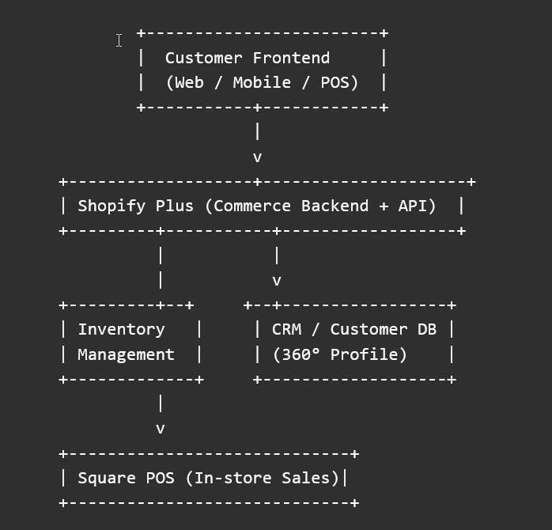

- Implementation roadmap
Key milestones for implementation within nine months

Milestone | Timeline | Description
Project Kickoff | Month 1 | Finalize vendors, assign teams, and set up environments
Data Cleansing & Migration Prep | Month 1 – 2 | Audit existing data, prepare mapping for products and customers
POS Hardware Upgrade | Month 2 – 3 | Replace outdated CE terminals with Square-compatible devices
Shopify Customization | Month 2 – 4 | Configure themes, product taxonomy, and install key integrations
Inventory System Sync | Month 4 – 5 | Enable real-time inventory updates and test across stores
Customer Data Integration | Month 5 – 6 | Sync customer data into CRM; test 360° profile visibility
Training & UAT | Month 7 | Train staff on POS and admin interfaces; perform user acceptance testing
Soft Launch / Pilot Store | Month 8 | Launch in pilot stores to test performance and gather feedback
Full Rollout | Month 9 | Expand deployment chain-wide in time for seasonal sales

